The Photoelectric Effect

Abstract:
By exploiting the Photoelectric Effect, we demonstrate the corpuscular nature of light, and experimentally deduce Planck’s constant, the constant of proportionality between the energy and frequency of a single light quantum.

Introduction:
In the early 20th century, Albert Einstein, excited with his recent work in Relativity and the Photoelectric Effect, wrote to a colleague to share his new ideas; the former contained interesting mechanics, he said, but the latter was truly revolutionary. Indeed, the Photoelectric Effect overthrew centuries-old classical theory which maintained that light was a wave, and helped cement the foundation of the Quantum Mechanical revolution. In this experiment, we examine the key features of the Photoelectric Effect; i.e., demonstrating contradictions to the classical theory of light waves and evidence for a theory of light quanta, measuring the proportionality between the energy and frequency of a light quantum, and measuring the work function, the energy needed to free an electron from the photoelectric plate.

Theory:
The classical theory of light allows an unbounded stopping potential. Continually pumping energy into the photoelectric plate energizes its electrons, eventually freeing them regardless of the anode-cathode potential they must overcome. This can be seen explicitly through simple algebra: If ∆N is the number of electrons that fly from anode to cathode in a small time interval ∆t, then ∆N is equal to the amount of energy available to electrons in ∆t divided by the amount of energy for a single electron to make the voyage; or, in symbols:
$∆N = (P ∆t – W ∆N)/ (e V)$, (Equation 1)
where P is the energy of incident light on the photoelectric plate per unit time, W is the amount of energy needed to merely free an electron from the photoelectric plate (i.e., the work function), e is the elementary charge, and V is the anode-cathode potential. In the limit of infinitesimal ∆t, the rate of departure from anode to cathode is:
$\frac{dN}{dt} = P / (e V + W)$. (Equation 2)
However, C V = e N, where N is the total transferred electrons, and C is the capacitance between anode and cathode. Thus, integrating (and imposing N(t=0) = 0):
$e^{2}N^{2} / (2 C) + W N = P t$, (Equation 3)
and hence,
$V = -W/e + {\left( {\left(\frac{W}{e}\right)}^{2}+2 C P t \right)}^{\frac{1}{2}}$, (Equation 4)
which, since the work function W itself is small compared to the total energy of the incident light, simplifies as:
$V = {\left( 2 C P t \right)}^{\frac{1}{2}}$. (Equation 5)
From this, since V ~ (P t)1/2, the potential is unbounded. Furthermore, the energy of light waves (and P) is proportional to the intensity of light. The intensity of light incident on the photoelectric plate (denoted I) must scale by the transmission factor (denoted f); i.e., I ~ f, and thus (at constant t) V ~ f1/2. Each of these predictions, as evidenced below, was not observed.
The energy of a single light quantum, termed photon, is given as E = h ν , where E is photon energy, ν is photon frequency, and h is Planck’s constant. Since the light is ‘localized’ in discrete packets, an electron can be dislodged by a single electron only. The photon energy, given to a single electron, is spent freeing the electron and giving the electron kinetic energy. However, since the energy of a single photon is clearly finite, the kinetic energy of the electron is finite as well. Thus, after enough electrons travel to the cathode, the potential will be too great for any electron freed by that color light to overcome. In symbols,
$E_{photon} = h ν ={\left(KE\right)}_{\max{}} + W$, (Equation 6)
and, if Vmax is the stopping potential, the potential which no freed electron can overcome,
$V_{stop} =\frac{h ν}{e} –\frac{W}{e}$. (Equation 7)

Procedure:
The experimental apparatus was as follows: A white light beam was shined from a mercury vapor lamp and, passing through a lens/diffraction grating, spread into a fan of its individual component colors. The location of the lens/diffraction grating was adjusted (in the direction of light propagation) to sharpen the resolution of light on the detector. The detector could be rotated to intercept any single maxima of the rainbow diffraction pattern. In addition, the detector window could be masked with up to three different filters: a yellow filter (i.e., one which allows only yellow light to pass through), a green filter, and an intensity filter, to block a fraction of incoming light regardless of color, which itself was subdivided into five subsections: 20%, 40%, 60%, 80%, and 100% transmission. When measuring a green or yellow maximum, their respective filters were used to mask ambient room light and overlying higher-order maxima from higher frequencies from the light source.
Inside the detector, light incident on the photoelectric plate, the anode, ejected electrons onto the cathode. Since the maximum kinetic energy of an ejected electron was limited by the energy, and thus the frequency, of the light quantum which dislodged it, once sufficient charge had accumulated on the cathode, the potential difference between anode and cathode would be too great for a single electron to surpass. The relationship between this potential difference (hereafter, termed ‘stopping potential’), the electron kinetic energy, and the photon energy and frequency will be examined in more detail later.
The experiment itself consisted of the following measurements: the stopping potential (measured by a digital multi-meter) and the time to reach the stopping potential (measured by a stopwatch), for both green and yellow light (first order maxima), at each of the five transmission factors; also, the stopping potential for five different colors (green, yellow, blue, violet, ultraviolet), at both their first and second maxima. As a reference, the following table lists pertinent information about each spectral line used in this experiment (table 1).

Table: 1
Color | Wavelength (nm) | Frequency (PHz)
Yellow | 578* | .518672
Green | 546.074 | .548996
Blue | 435.835 | .687858
Violet | 404.483 | .740858
Ultraviolet | 365.483 | .20264

Analysis:
Consequently, if frequency is held constant, the stopping potential should be constant as well, regardless of transmission factor. This can be verified analytically upon investigation of Equation 7, which is nonetheless experimentally determined untrue. This violation of the classical wave theory of light is shown below (fig. 1 & 2).

Figure: 1 Figure: 2
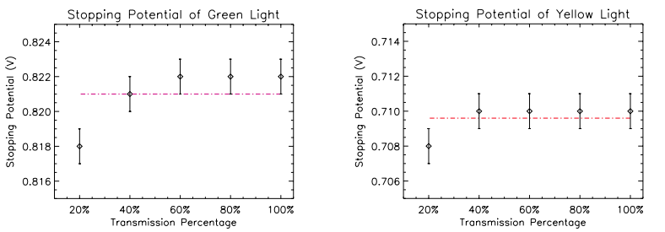
figure 1 (left) & 2 (right): Error bars reflect + .001 uncertainty in Digital Multimeter measurement. Least-squares constant fit (a simple average, in this case) over plotted in red (χ 2 fig1 = 1.2x10-5; χ 2 fig2 = 3.6x10-6). Note that for low transmission, the flow of photons and consequent ejected electrons is no longer sufficient to overwhelm the ~pAmp leakage from the cathode, resulting in a slightly lower potential for lower transmission percentage.

The time to effect Vstop is proportional to 1/f, shown in fig. 3 & 4; directly in frequency compliance with Equation 7.
Figure: 3 Figure: 4
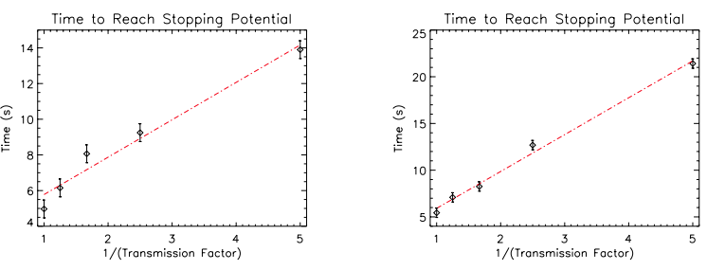
figure 3 (left) & 4 (right): Error bars reflect the + 0.5 s uncertainty in human reaction time. A linear least-squares fit is over plotted in red, reflecting the proportionality of Vstop and 1/f (χ 2 fig1 = 1.6; χ 2 fig2 = 1.2).

Since Vstop is a linear function of ν, the polynomial constants ( h / e ) and ( W / e ) can be determined through a linear fit of the measured Vstop versus frequency. Fig. 5, below, show these fits individually with light from the diffraction pattern’s first and second order maxima.

Figure: 5
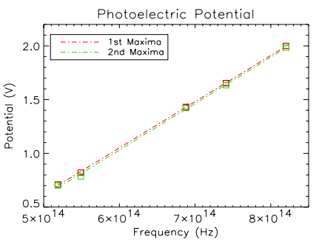
figure 5: Error (not shown) is + 0.001 V. Red indicates 1st order maximum data and fits; green indicates 2nd order. Leastsquares linear fits are shown as dashed lines (χ 2 1st = 2.0 x 10-4; χ 2 2nd = 1.3 x 10-3 ). Data points are shown as boxes. All potentials were measured at 100% transmission.

Because the elementary charge is known ( e = 1.6 x 10-16 C ), one can solve for the work function and Plank’s constant. Utilizing Equation 6 and Equation 7:

Table: 2
Quantity of interest | Plank’s Constant | Work Function
1st Order Result | 6.88x10^(-34) J s | 2.45x10^(-19) J
2nd Order Result | 6.91x10^(-34) J s | 2.50x10^(-19) J s
Accepted Values | 6.663x10^(-34) | *
table 2: Summary of results and accepted values. * Note: Work function of the photoelectric plate was unknown

Discussion of Results:
The calculated values of Planck’s constant and the work function are in agreement, since the first order and second order results lie within each others’ ranges of uncertainty. However, both of the experimental values of Planck’s constant are multiple standard deviations greater than the accepted value. Consequently, there must be some systematic error which still lurks uncounted. Several possibilities will be entertained presently:
Ambient light in the laboratory could have entered the detector during the experiment, skewing the data. We measured Vstop(ν) twice more, once with the laboratory full illuminated, and once in complete darkness; and we discovered no change between measurements. This cannot be the hidden source of our uncertainty.
The leakage current could have affected our data. However, greater potentials correspond to greater leakage current, by Ohm’s Law, so this effect would be more pronounced for higher frequency light (as is seen, very briefly, in figures 1 & 2). As a result, the Vstop(ν) curve would be less steep, reducing our measured value of Plank’s constant. This cannot be the hidden source of our uncertainty either.
The yellow and green filters may have been inadequate, insufficiently blocking high frequency light. These unwelcome high energy photons would have ejected high energy electrons, allowing them unofficially to surpass the cathode-anode potential, consequently increasing the measured stopping potential. This effect would have increased Vstop for green and yellow light, flattening the Vstop(ν) curve, reducing our measured value of Plank’s constant. Again, this cannot be the source of uncertainty.

Conclusion:
In light of all of this, the fault must lie within the inner workings of the photoelectric device or the digital multimeter. To analyze this problem in more depth, the experiment must be performed again with another set of apparatus. But even with this slightly flawed experiment, the real triumph appears indisputible, i.e., clear evidence that light is not completely wavelike, but possesses, in at least one respect, corpuscular aspects as well.

